



**ASSIGNMENT**

TOPIC:FAMOUS PEOPLE

Name: Nguyen Van Huy

SID:PH06578

Class:ENT1123.24

Instructor and advisor: Ly Thi Loan

Ha Noi, 1th November, 2017

**OUTLINE**

1. **Introduction**
2. **Body**
3. **Early Life**
4. **Career**
5. **Personal Life**
6. **Achievement**
7. **Conclusion**

**Mr.Truong Gia Binh**

1. **Introduction**

Among the famous businessman in Viet Nam, Truong Gia Binh is the person I admire most.

**Truong Gia Binh** is a [Vietnamese](https://en.wikipedia.org/wiki/Vietnam) businessman who is best known as the co-founder, chairman and CEO of the Vietnamese technology company FPT Corporation.

Mr. Truong Gia Binh is now the Chairman of Vietnam Software and IT Services Association (VINASA) in the period 2016-2020.

.

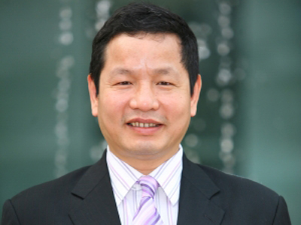

1. **Body**

**Early life**

Truong Gia Binh was born in 1956 in Nghe An province into knowledge family.His father, Truong Gia Tho, was a doctor in Hanoi. Binh attended Chu Van An highschool in Vietnam, and then went to the Soviet Union for college.Mr. Binh graduated from Mechanical Mathematics Department of Moscow National General University named Lomonosov of the former Soviet Union, which is now Russian Federation in 1979. He successfully obtained his PhD. in 1982 in this university and was honored as an Associate Professor by the State of Vietnam in 1991.

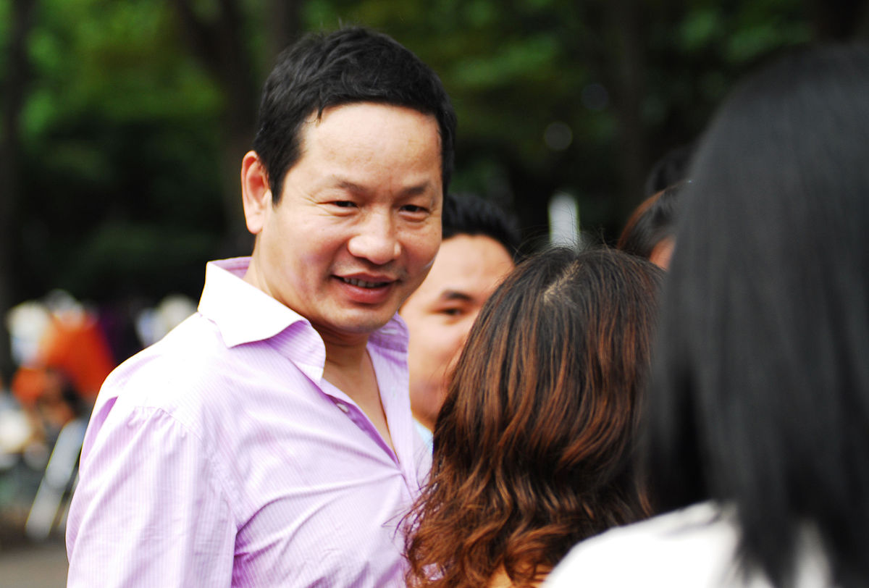

**Career**

On September 13, 1988, Binh and 12 Vietnamese scientists founded the Food Processing Technology company, the predecessor of FPT. He became the head of the [Corporation for Financing and Promoting Technology](https://en.wikipedia.org/wiki/Corporation_for_Financing_and_Promoting_Technology), Vietnam's earliest [information technology](https://en.wikipedia.org/wiki/Information_technology) firm, in 1990.

In March 2002, after the equitization of FPT, Binh became the Chairman and Chief Executive Officer (CEO) of FPT Corporation. Afterwards, he led the firm in its expansion from its origins as an [internet service provider](https://en.wikipedia.org/wiki/Internet_service_provider) to other areas such as software [outsourcing](https://en.wikipedia.org/wiki/Outsourcing) for Japanese companies.

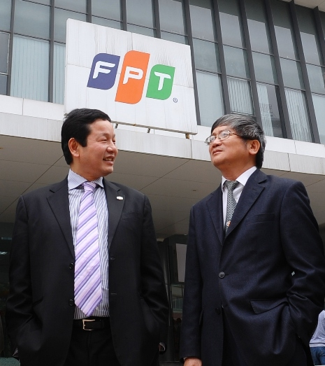

In 2006, his company opened [FPT University](https://en.wikipedia.org/wiki/FPT_University), Vietnam's first private university; he also took up a position as the chairman of its managing board.He is speculated to be the richest person in Vietnam; as of January 2007, the value of his stake in FPT alone is [VND2.6](https://en.wikipedia.org/wiki/Vietnamese_%C4%91%E1%BB%93ng) trillion ($164 million; 5,117,280 shares at VND525,000), according to the company's own prospectus. Binh himself is reportedly "tired" of the rumours.

On July 16, 2012, Truong Gia Binh was appointed to a member of the National Council for Sustainable Development and Competitiveness Building. The council, chaired by Vietnam's Deputy Prime Minister Nguyen Thien Nhan, is tasked with developing strategies and key policies to set orientations and a legal framework for the country’s sustainable development in the next decade.

**Achievement**

In February 2010, Binh was voted by the Post Newspaper, the voice of the Ministry of Information & Communications and ICT journalists from over 30 popular newspapers in Vietnam as one of the Vietnam's Top 10 ICT Persons of the Decade (2000-2009).

In 2013, Truong Gia Binh was awarded [Nikkei Asia Prize](https://en.wikipedia.org/wiki/Nikkei_Asia_Prize) 2013. Dr. Truong is the first Vietnamese entrepreneur to be honored by Nikkei Inc. in 18 years.

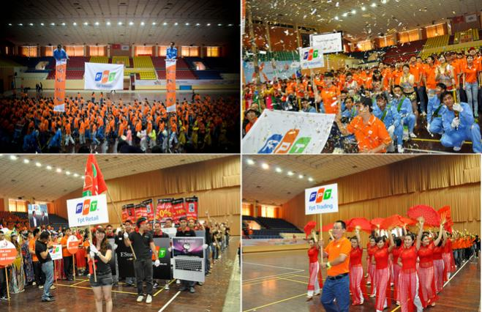

1. **Conclusion**

I am now also a students at FPT Polytechnic, I realy admire Mr.Truong Gia Binh and Appreciate his contribution to FPT corporation.

